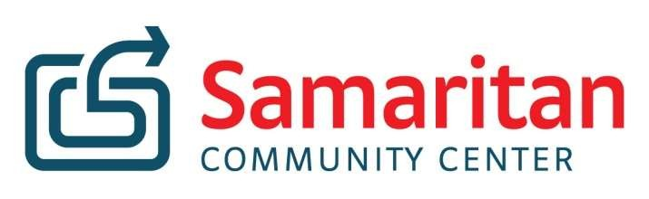

Dear Parent(s):

The Samaritan Community Center is partnering with schools to provide sacks of food to eligible children on a weekly basis through the SnackPacks for Kids program. The program will provide 6-10 food items to students so they will have food available for the weekend. These snack bags will be distributed to students discreetly each week by your child’s school counselor.

The following is an example of the possible food items that may be included (not will be included). Shelf Stable 1% Milk, Pudding Cups, Fruit Snacks, Breakfast Cereal, Sunflower seeds, Meat Sticks. SOME ITEMS MAY CONTAIN NUTS OR MAY HAVE BEEN PROCESSED IN A FACILITY WHERE NUTS ARE PRESENT.

Your child has been selected to participate in this program. If you would like your child to participate in this program, please complete the information below, sign this letter, and return it to the school counselor.

Sincerely,

Jon Rambo
SnackPack for Kids Coordinator
jrambo@samcc.org 479-636-4198

Parental Permission Slip:

I (the undersigned parent or legal guardian) agree to allow my child or children to participate in the
SnackPacks for Kids Program. I have read the list of food items shown above and have no objection to SnackPacks for Kids providing these or similar food items to my child to take home on the weekends.

I also consent to my child participating in Samaritan Community Center’s anonymous yearly survey facilitated by my child’s school staff which help SnackPacks best meet my child’s needs. Scan to view survey questions.

Child Name (Please Print) ___________________________________

Parent or Legal Guardian Name (Please Print) _________________________________

Parent or Legal Guardian Name (Please Sign) _________________________________

Date ____________________

8

